1. What is Boolean

Boolean value is either true or false

Examples of Boolean

5==6

>>> false

5!=6

>>> true

5 >3

>>> true

2.Flow Chart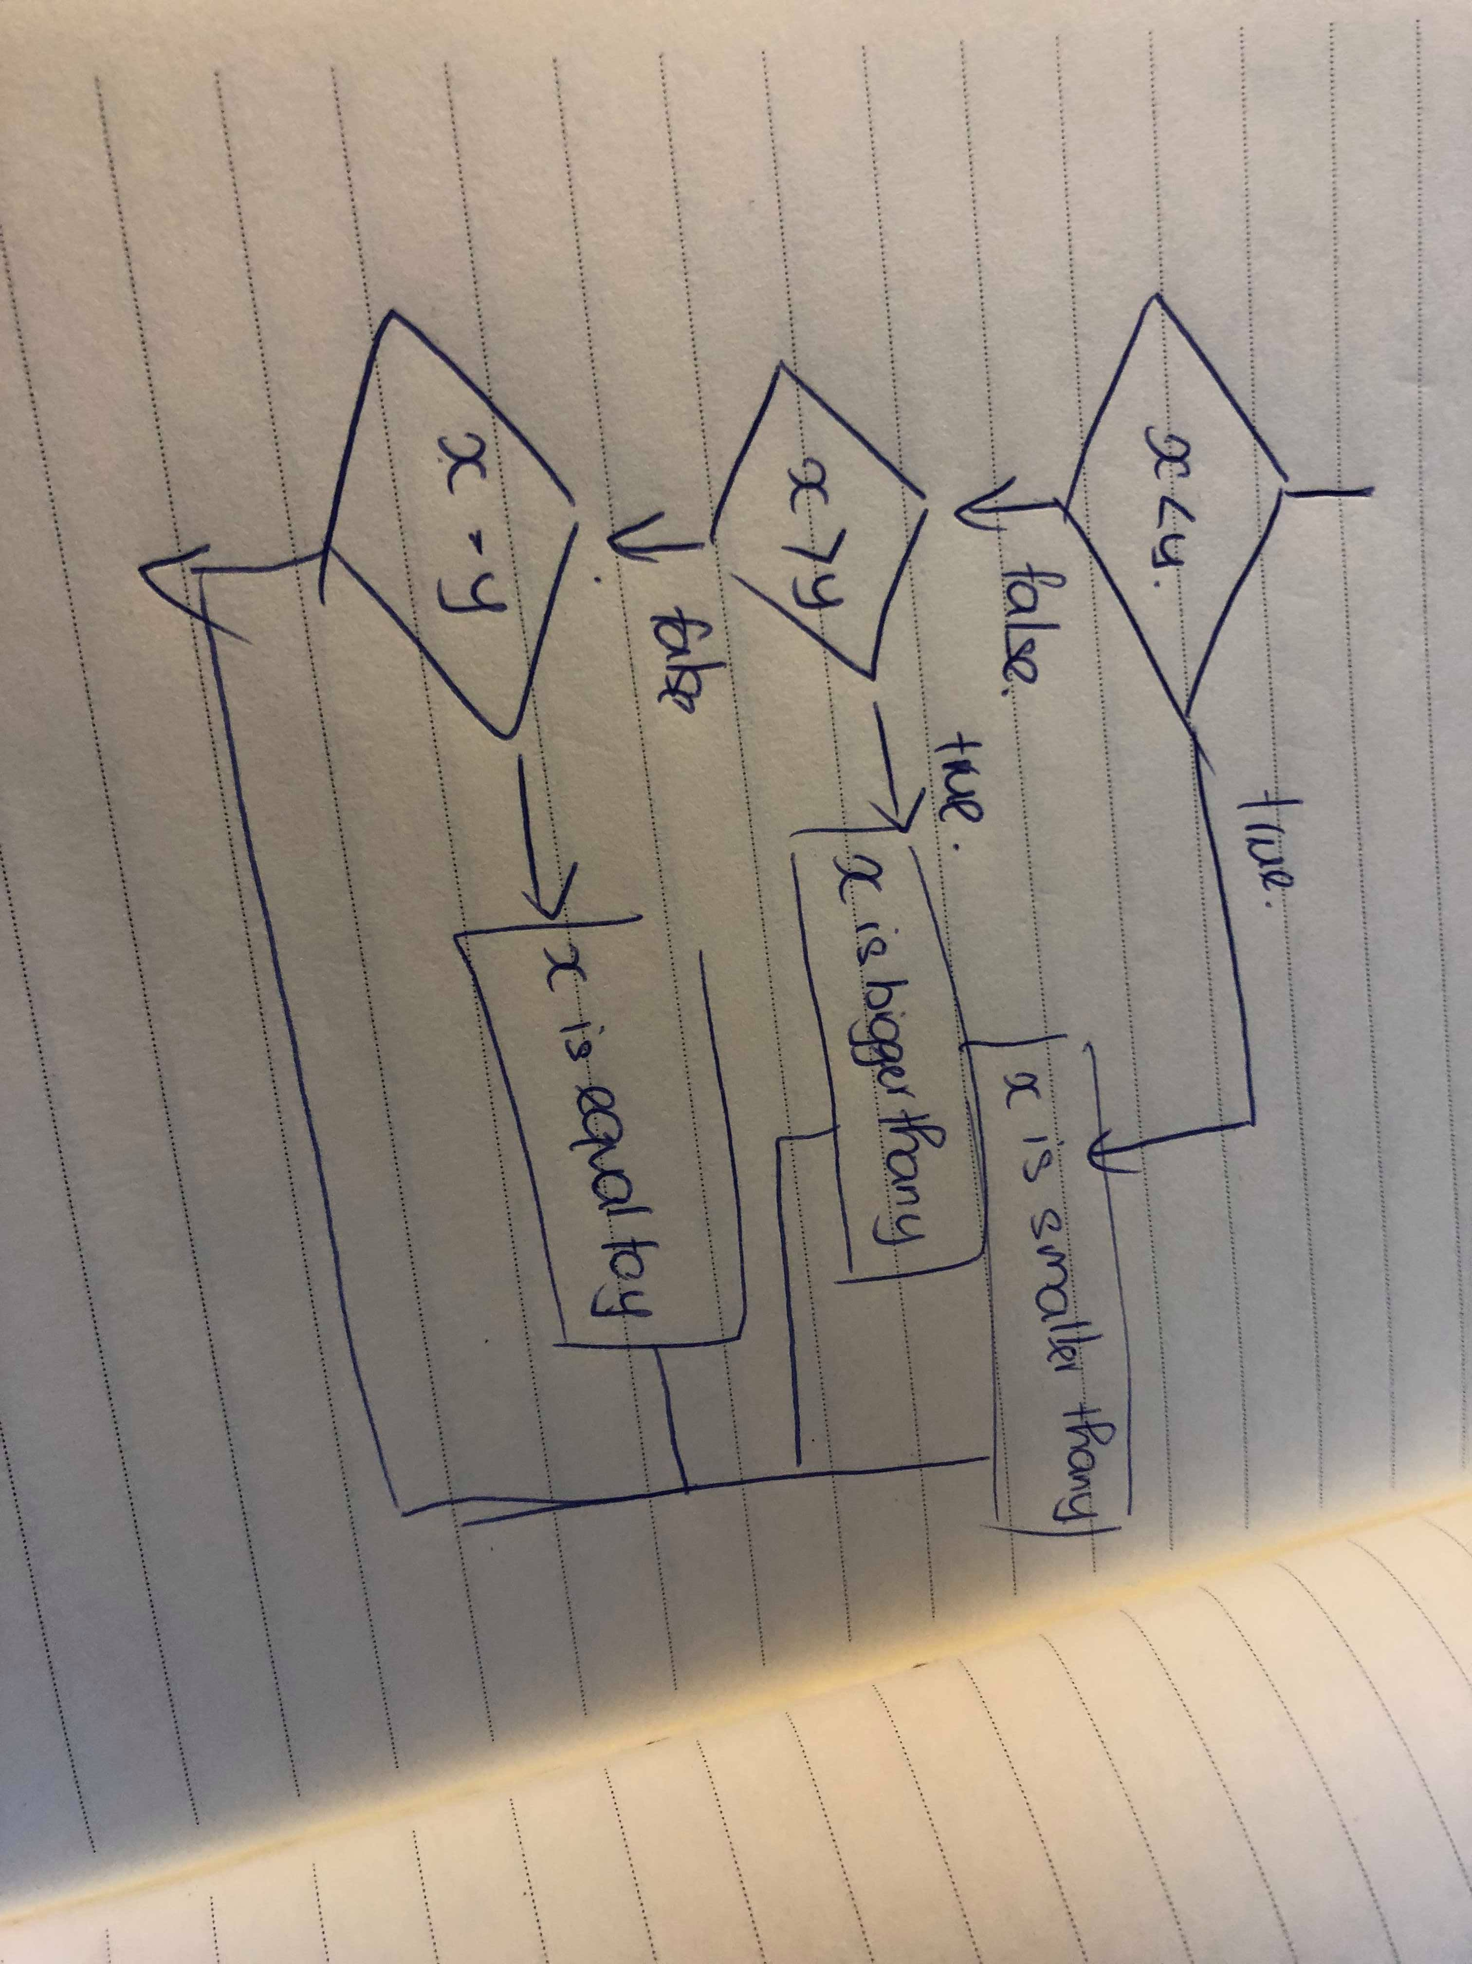

3.Nested Condition

If a< b:

Print(“a is smaller than b”)

Ifel a>b:

Print(“a is biggest than b”)

Else:

Print(“a is equal to b”)

**Turtle1**

from turtle import*

shape("turtle")

color(“red”,”white”)

for i in range(2):

left(30)

forward(100)

right(60)

forward(100)

right(120)

forward(100)

right(60)

forward(100)

left(30)

left(30)

forward(100)

right(60)

forward(100)

right(120)

forward(100)

right(60)

forward(100)

left(30)

left(90)

mainloop()

**Turtle2**